The aim is to develop a machine learning model that can predict whether a patient is affected by Chronic Kidney Disease (CKD) based on several medical parameters. The dataset was provided to build an accurate predictive model for disease classification.

Dataset info:
Dataset Name: CKD.csv
Number of Rows: 400
Number of Columns: 25
Target Variable: Classification
The dataset contains various medical attributes such as age, blood pressure, blood glucose level, blood urea, serum creatinine, sodium, potassium, haemoglobin and other health-related factors that are useful in identifying Chronic Kidney Disease.

Preprocessing:
- Loaded the dataset using Pandas.
- Converted categorical variables into numerical format using pd.get_dummies().
- Used drop_first=True to avoid dummy variable redundancy.
- Split the dataset into training and testing datasets using Train-Test Split.
- Training data: 67%
- Testing data: 33%

ML Models used:
- Support Vector Machine (SVM)
- Random Forest
- Decision Tree
- Logistic Regression
- K-Nearest Neighbors (KNN)
- Gaussian Naive Bayes
- Multinomial Naive Bayes
- Bernoulli Naive Bayes
- Complement Naive Bayes
Model evaluation results
S.No | Algorithm | Accuracy
1 | Random Forest | 98.50%
2 | GaussianNB | 97.74%
3 | BernoulliNB | 93.98%
4 | Logistic Regression | 93.98%
5 | Decision Tree | 92.48%
6 | ComplementNB | 81.95%
7 | MultinomialNB | 81.95%
8 | KNN | 69.17%
9 | SVM | 61.65%

Selected Model: Random Forest Classifier, Accuracy: 98.50%
Random Forest produced the highest accuracy among all the machine learning algorithms tested. It outperformed Gaussian Naive Bayes, Logistic Regression, Decision Tree, KNN and SVM models.
Advantages of Random Forest:
- Highest prediction accuracy.
- Handles large datasets effectively.
- Reduces overfitting through ensemble learning.
- Provides robust and reliable classification performance.
Therefore, Random Forest was selected as the final model for predicting Chronic Kidney Disease.

Screenshots:
Random Forest classification report:
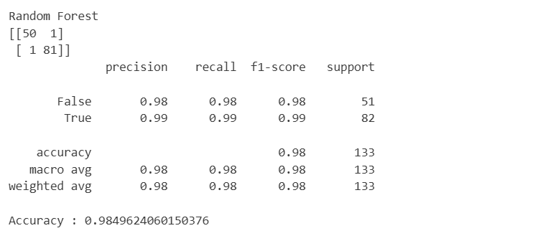

Final accuracy comparison table:
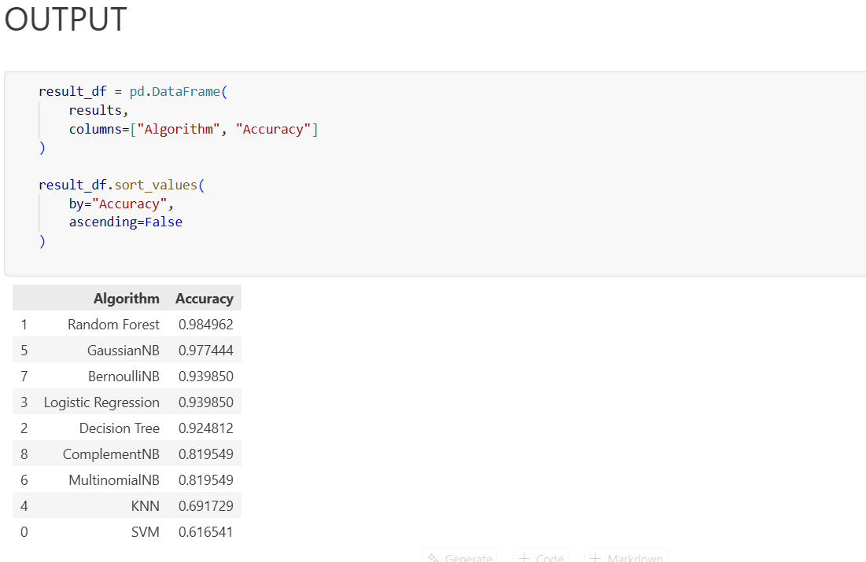
Conclusion
In this, multiple machine learning classification algorithms were applied to the CKD dataset. After preprocessing and evaluation, the Random Forest Classifier achieved the highest accuracy of 98.50%. Hence, it was chosen as the final predictive model for classification.

